73rd Independence Day was celebrated at Sai Samarpan with the Special Children of Sai Samarpan and the Special invitees Special Children and their parents of CLAPS a Community Living Association of Parents of Special Citizens which is closely associated with Sai Samarpan.
2. The Flag hoisting was done by Special Child Ms.Gayathri Bhaskar who had also her birthday falling on this Day. Sweets were distributed to all by the Sai Samarpan Trustees and a sumptuous breakfast was arranged for all by the CLAPS Association Parents who had assembled for the Celebration.
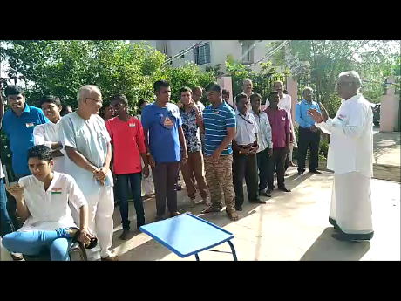
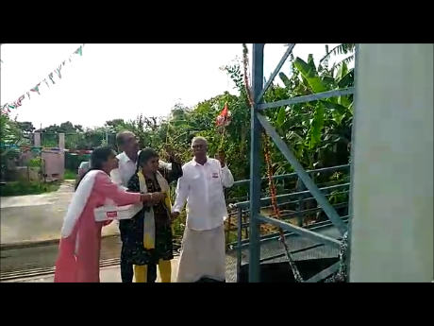
d